ECAT Exam Application Report
Course: Fundamentals of Programming & Data Science
Project: ECAT Exam Application - Dual Portal System
Language Used: Python

1. Introduction
This project is a simple ECAT Exam Application made in Python. The system contains two portals: Admin Portal and Student Portal. The admin can view questions and student results, while students can log in and attempt the MCQ exam.

2. Objectives
- Create a simple exam system using Python.
- Allow students to attempt MCQs.
- Allow admin to manage and view results.
- Store data using lists and dictionaries.

3. Features of the System
- Admin Login System
- Student Login System
- MCQ Based Exam
- Automatic Result Calculation
- Grade Calculation
- Question Viewing
- Student Result Storage

4. Python Concepts Used
- Variables
- Lists
- Dictionaries
- Functions
- Loops
- Conditional Statements
- Input and Output

5. Architecture Diagram
The following diagram shows the working structure of the ECAT Exam Application.

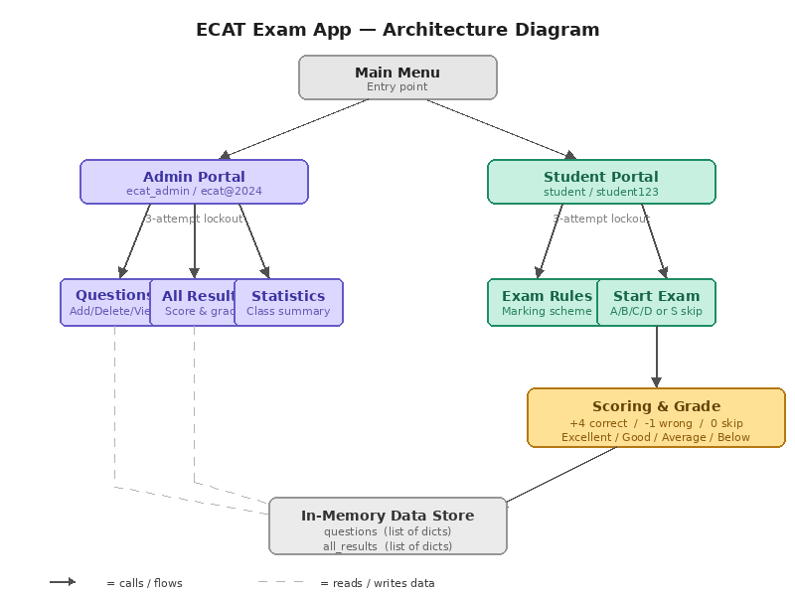
6. Working of the Program
When the program starts, the user selects either Admin Portal or Student Portal. The admin can view questions and results. The student logs in, attempts MCQs, and the system calculates score, percentage, and grade automatically.

7. Conclusion
This project helped in understanding basic Python programming concepts such as loops, functions, lists, and dictionaries. It is a beginner-friendly exam management system.

